ORTHOPAEDIC INSTRUMENTS
Other Instruments
Amputation Saw
Intended Use
The amputation saw is a large-frame bone saw used to divide long bones during limb amputation procedures in veterinary patients. It provides the stable, straight cuts needed to section femoral, humeral and tibial diaphyses cleanly during forequarter, hindquarter and mid-limb amputation in dogs and cats. | 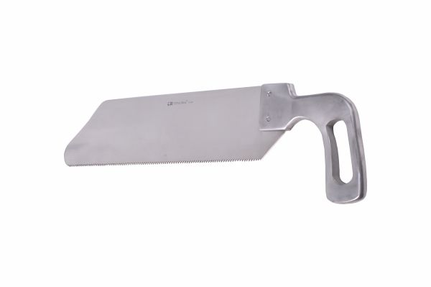
Function
A broad, rigid blade with coarse, hardened teeth is drawn in long strokes through the bone. The wide blade prevents blade walking that narrows saws exhibit, maintaining a straight cut plane across the full bone diameter. The frame handle provides the force and stroke length needed for single-pass amputation bone division.
Advantages
Broad Blade Stability: The wide frame blade resists lateral flex during the cut, producing a flat, straight transection surface without the curved or stepped cuts that narrow blades make when they deviate from the cut plane in dense diaphyseal cortex.
Single-Pass Efficiency: The long stroke and coarse tooth geometry allows amputation cuts to be completed in fewer strokes than fine-toothed saws, reducing operative time and anaesthetic duration in emergency limb amputation procedures.
FAQ
Q: Should the periosteum be stripped before amputation sawing?
A: The periosteum is typically stripped 1–2 cm proximal to the planned cut to prevent periosteal tenting that interferes with saw blade tracking and to ensure a clean cortical surface for wound closure.
Q: Can the amputation saw be used for osteotomy procedures?
A: Standard amputation saws produce rough cut surfaces less suitable for precision osteotomies; oscillating saws with fine blades are preferred for reconstructive osteotomies requiring smooth, accurate cut surfaces.

ORTHOPAEDIC INSTRUMENTS
Other Instruments
Bone File – Rasp
Intended Use
The bone file-rasp is a smoothing instrument used to refine cut bone surfaces after osteotomy, amputation or fracture reduction in veterinary orthopaedic surgery. It removes rough edges, bone spicules and saw marks that could cause soft tissue irritation, delayed wound healing or implant interference in the post-operative period. | 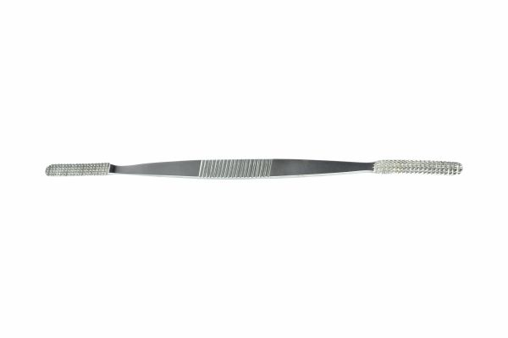
Function
Multiple raised cutting teeth or ridges on the working face remove thin layers of bone material when the file is drawn across the surface. The cross-cut file pattern removes material on both the push and pull strokes, allowing efficient surface smoothing in both directions without requiring the blade to be lifted between strokes.
Advantages
Implant Surface Optimisation: Filing bone surfaces before plate application creates a flatter, more uniform contact area that allows plates to seat without rocking — an important step for maximising plate-to-bone contact area and the frictional resistance that reduces plate micromotion.
Amputation Stump Refinement: Smoothing amputation bone ends with the rasp removes sharp cortical spicules that could penetrate the soft tissue flap and cause stump wound dehiscence — a leading cause of post-amputation complication in veterinary patients.
FAQ
Q: How is the bone file cleaned after use?
A: Immediately after use, scrub across the teeth with a file card or stiff wire brush under running water to remove packed bone debris; clogged teeth become ineffective and are difficult to clean after debris dries.
Q: Can a bone rasp be used on cartilage?
A: Bone rasps are not intended for cartilage; use a dedicated cartilage burr or motorised shaver for cartilage preparation in joint arthrodesis and arthroplasty procedures.

ORTHOPAEDIC INSTRUMENTS
Other Instruments
Bone File with Fibre Handle
Intended Use
The bone file with fibre handle is used for smoothing and contouring bone surfaces in veterinary orthopaedic surgery. The fibre handle provides a comfortable, non-slip grip and eliminates heat conduction to the surgeon's hand during use, making prolonged filing sequences comfortable and controlled in complex bone contouring procedures. | 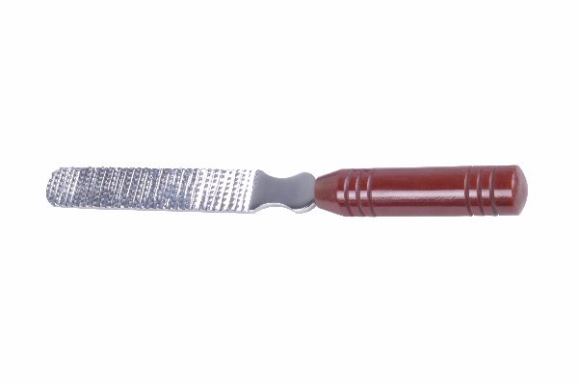
Function
The hardened steel file face carries parallel or cross-cut teeth that shave bone material when moved across the surface. The fibre handle transmits the feel of the file-to-bone contact to the surgeon's hand, providing tactile feedback that signals surface roughness changes as filing progresses toward a smooth endpoint.
Advantages
Ergonomic Extended Use: The fibre handle's cushioned grip reduces hand fatigue during prolonged filing in complex bone contouring procedures such as femoral head and neck resection arthroplasty, where achieving a smooth femoral stump requires extensive filing to prevent post-operative crepitus.
Non-Conductive Material Safety: The non-metallic fibre handle prevents galvanic transfer between the steel file and metallic implants in the wound, and eliminates heat conduction from steam sterilisation residual warmth to the surgeon's hand.
FAQ
Q: When is filing preferred over power burring for bone smoothing?
A: Manual filing is preferred in delicate anatomical locations near neurovascular structures where power burr heat generation and unpredictable bite depth risk injury; power burrs are more efficient for large surface areas in open procedures.
Q: What grit equivalent is a standard bone file?
A: Bone files are typically medium-coarse equivalent (80–120 grit), removing material efficiently while leaving a surface smooth enough for direct plate contact without further preparation.

ORTHOPAEDIC INSTRUMENTS
Other Instruments
Calipers Castroviejo
Intended Use
Castroviejo calipers are precision measurement instruments used in veterinary ophthalmic and orthopaedic surgery to measure distances on tissue and bone with millimetre accuracy. In orthopaedics they are used to measure plate length, fragment dimensions, and gap widths to guide implant selection during small bone fracture fixation. | 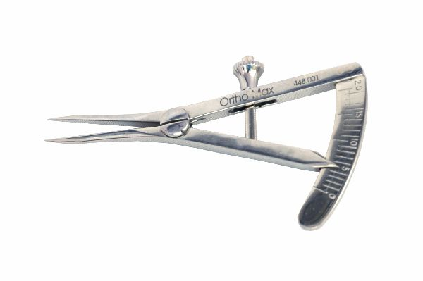
Function
Two fine-pointed tips are spread to the measurement distance by thumb-wheel or spring adjustment. A calibrated vernier or dial scale on the instrument body reads the distance between the tips directly in millimetres. The lock screw maintains the set distance while the instrument is removed from the wound for scale reading.
Advantages
Millimetre Measurement Accuracy: The Castroviejo caliper provides direct tissue measurement to 0.5 mm accuracy without the magnification errors that visual estimation introduces, ensuring implant sizes are based on precise dimensional data rather than surgeon estimation.
Fine-Pointed Tips for Delicate Tissue: The slim, atraumatic pointed tips measure distances between fragile tissue or bone structures without displacing or damaging them — critical in ophthalmic surgery and in measuring fragment lengths in small breed and feline fracture cases.
FAQ
Q: How are Castroviejo calipers used for plate length selection?
A: The tips are placed at the planned proximal and distal screw positions, and the scale reading is compared to available plate lengths; the plate should span at least 3 plate holes beyond the fracture on each side.
Q: Can the caliper be used intraoperatively on wet tissue?
A: Yes — the stainless steel construction is unaffected by blood and saline; ensure the lock screw is engaged before removing from the wound to maintain the measurement.

ORTHOPAEDIC INSTRUMENTS
Other Instruments
Doyen Mouth Gag
Intended Use
The Doyen mouth gag is a self-retaining instrument used to maintain the mouth in the open position during oral, dental, and oropharyngeal surgical procedures in veterinary patients. It prevents the patient from closing the mouth on instruments or the surgeon's hands during oral cavity examination and procedures under general anaesthesia. | 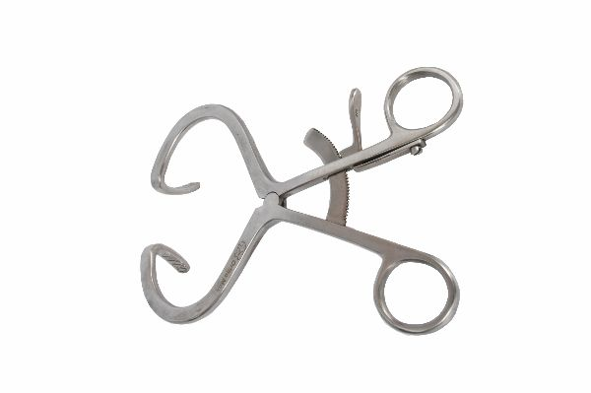
Function
Two ratchet-linked cheek pads are placed between the upper and lower dental arcades on each side. The ratchet is opened to the required interincisal distance and locked, holding the mouth open at a stable, controlled gape. The cheek pad design distributes the opening force across multiple teeth to prevent dental fractures.
Advantages
Stable Hands-Free Mouth Opening: The self-retaining ratchet mechanism holds the mouth at the required gape without an assistant's hand, allowing the surgeon and assistant to work freely within the oral cavity during extended dental, oral mass removal or palate repair procedures.
Dental Pressure Distribution: Broad cheek pads contact multiple teeth simultaneously, distributing the retraction force to avoid the concentrated load on individual teeth that pointed gags cause, reducing the risk of iatrogenic dental fractures in toy breeds with small teeth.
FAQ
Q: What interincisal distance is safe for veterinary mouth gags?
A: Prolonged opening beyond 2.5–3 cm in cats risks temporomandibular joint injury and ischaemic brainstem complications; use the minimum gape required and release the gag every 15–20 minutes to restore temporomandibular perfusion.
Q: Is the Doyen gag used for all veterinary species?
A: Doyen gags are designed for dogs and cats; equine mouth gags are a different design (full-mouth speculum); the Doyen is not suitable for large animal dental procedures.

ORTHOPAEDIC INSTRUMENTS
Other Instruments
Ferguson Mouth Gag
Intended Use
The Ferguson mouth gag is a side-bar self-retaining mouth opener used in veterinary dental and oral surgical procedures to maintain consistent, adjustable mouth opening. The side-bar design provides unobstructed access to the front of the oral cavity, making it particularly useful for anterior dental extractions and palate procedures. | 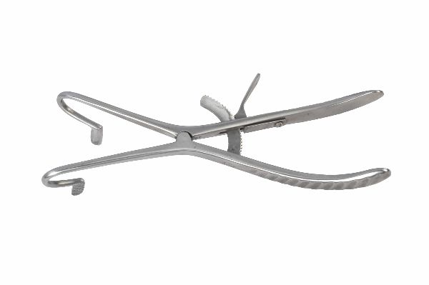
Function
Two hinged mouth plates are placed over the upper and lower teeth on one side of the mouth. The side ratchet mechanism adjusts and locks the plate separation, holding the mouth open at the desired gape. The contralateral side of the mouth remains unobstructed, providing full anterior access during the procedure.
Advantages
Anterior Oral Access: The side-bar mounting leaves the anterior oral cavity and lips completely unobstructed, giving unimpeded access for anterior dental extractions, lip and labial frenectomy, and philtrum surgery that a bilateral central gag would obstruct.
Adjustable, Lockable Gape: The ratchet mechanism provides incremental adjustment to match each patient's comfortable maximum gape, which varies significantly between breeds; this prevents the over-opening that occurs when fixed-width gags are applied to patients with smaller interincisal distances than the gag is designed for.
FAQ
Q: How does the Ferguson gag differ from the Doyen gag?
A: The Ferguson is a unilateral side-bar design providing anterior access; the Doyen is bilateral with cheek pads providing more symmetrical lateral opening. The choice depends on the surgical access requirements.
Q: Can the Ferguson gag be used in cats?
A: Yes, but with caution — cats have a small temporomandibular joint and low tolerance for wide gaping; use the smallest effective gape setting and apply for the minimum necessary time.

ORTHOPAEDIC INSTRUMENTS
Other Instruments
Fickling Dental Mallet
Intended Use
The Fickling dental mallet is a precision impact instrument used in veterinary dental and oral surgery to drive chisels, osteotomes, elevators and bone gouges during tooth extraction, alveolar bone removal, and oral reconstructive procedures. Its controlled impact force is suited to the delicate bone of the dental arcade. | 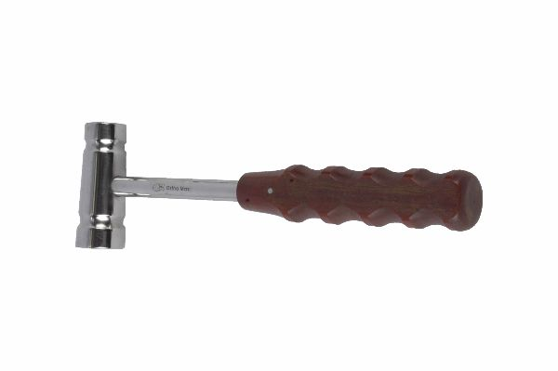
Function
A weighted cylindrical head delivers consistent, controlled impact force when dropped or swung against the instrument handle. The mallet head material — typically nylon, resin or brass — is chosen to deliver impact without instrument rebound, transmitting maximum energy per strike to the dental instrument being driven.
Advantages
Dental Bone Impact Calibration: The mallet head weight and material are calibrated for the moderate, controlled impact forces used in dental bone work — heavier surgical mallets deliver excessive force that risks alveolar bone fracture and periodontal ligament disruption during veterinary dental extractions.
Reduced Instrument Rebound: Nylon or resin heads minimise rebound after each strike, allowing the driven instrument to remain engaged in the bone between blows — standard metal-on-metal mallets cause significant rebound that repeatedly displaces the instrument from its working position.
FAQ
Q: What materials are Fickling dental mallet heads made from?
A: Common head materials are nylon (firm, durable), resin (medium impact, widely used), and brass (maximum impact for dense alveolar bone); the choice depends on the specific dental procedure and the patient's bone density.
Q: Can a standard orthopaedic mallet be used instead?
A: Standard orthopaedic mallets are too heavy for dental procedures; they deliver excessive force that risks tooth root fragmentation, alveolar fracture and periodontal injury in the delicate dental anatomy of small animal patients.

ORTHOPAEDIC INSTRUMENTS
Other Instruments
Finger Saw
Intended Use
The finger saw is a flexible wire saw used for bone division in confined anatomical locations where standard saws cannot access, particularly for digit amputation, toe bone resection and small bone osteotomy in veterinary patients. The flexible wire navigates around bones to achieve saw cuts from any angle. | 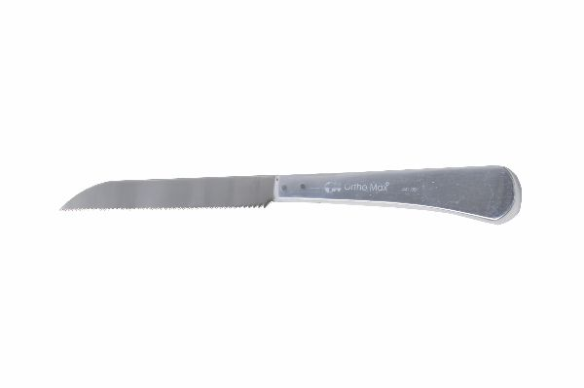
Function
A thin, abrasive or serrated wire loop is passed around or through the target bone. Handles at each end allow the surgeon to draw the wire back and forth across the bone in a sawing motion. The flexible wire follows the bone surface closely, creating a cut at the exact level of wire placement without damaging adjacent soft tissue.
Advantages
Any-Angle Bone Division: Unlike rigid saws that require a straight approach path, the flexible finger saw can be positioned at any angle relative to the bone axis, enabling bone cuts in anatomical locations where rigid blades cannot be directed safely.
Minimal Adjacent Tissue Damage: The fine wire kerf and the ability to keep the wire against the bone surface minimises soft tissue disruption during cutting, reducing the tissue damage that creates post-operative oedema and complicates wound healing in digital surgery.
FAQ
Q: What procedures most commonly use the finger saw in veterinary orthopaedics?
A: Digit amputation at the proximal interphalangeal or metacarpophalangeal joint, dewclaw removal and phalangeal fracture repair are the most common veterinary applications for the flexible finger saw.
Q: How is the wire saw passed around a bone?
A: A curved Gigli saw introducer or a loop of suture is used to pass the wire around the bone in a subperiosteal plane before the sawing handles are attached to each end.

ORTHOPAEDIC INSTRUMENTS
Other Instruments
Gigli Saw Guide
Intended Use
The Gigli saw guide is a curved conductor instrument used to pass the Gigli wire saw safely around a bone in a subperiosteal plane prior to sawing. It protects surrounding neurovascular structures from the wire during passage and ensures the wire is correctly positioned for a controlled, accurate bone cut. | 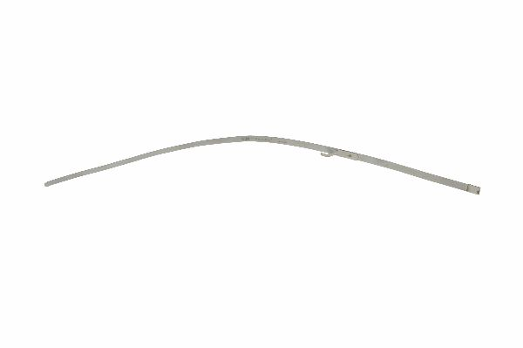
Function
The curved guide tip is introduced in the subperiosteal plane and passed around the bone until the tip emerges on the other side. The Gigli wire threaded through the guide's eye is pulled through with the guide, emerging from both sides of the bone in the correct position for sawing. The guide is then removed and the saw handles attached.
Advantages
Safe Subperiosteal Wire Passage: The smooth, blunt guide tip navigates the subperiosteal space around the bone without lacerating the periosteum or the adjacent neurovascular structures, ensuring the wire emerges in the correct anatomical plane for a controlled cut.
Accurate Wire Positioning: The guide deposits the wire at precisely the intended bone level, avoiding the accidental malpositioning that occurs when wires are passed blindly — malpositioning would produce an angled or stepped cut rather than the clean perpendicular transection required.
FAQ
Q: Can the Gigli saw guide be used for mandibular resection in dogs?
A: Yes — the curved guide passes around the mandible in the subperiosteal plane for Gigli wire placement during partial mandibulectomy or mandibular symphyseal fracture repair procedures in dogs.
Q: How is the guide tip kept in the subperiosteal plane?
A: The tip is maintained in contact with the bone cortex during passage; losing bone contact allows the tip to enter the soft tissue plane where neurovascular structures are at risk.

ORTHOPAEDIC INSTRUMENTS
Other Instruments
Gigli Saw Handle In Pair
Intended Use
Gigli saw handles in pair are used to hold and operate the Gigli wire saw during bone division in veterinary surgery. Each handle is attached to one end of the Gigli wire and used to draw the wire back and forth across the bone in alternating pulling motions to complete the bone cut. | 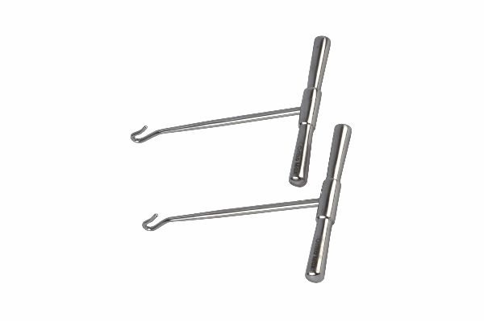
Function
The handles thread or clip onto the looped wire ends. The surgeon holds one handle in each hand and alternately pulls each handle in a sawing motion, drawing the wire across the bone surface. The rigid handles prevent the wire from kinking at the surgeon's grip points during the rapid reciprocating sawing action.
Advantages
Bilateral Controlled Sawing Force: Paired handles allow the surgeon to apply equal, alternating pull force from both sides of the bone, producing a smooth, uniform cut rather than the angled cut that results from unequal force application from a single handle.
Wire Kink Prevention: The rigid handle attachment point prevents the wire from bending sharply at the grip, which would rapidly fatigue the wire at the kink point and cause wire breakage during the cut — a serious intraoperative complication.
FAQ
Q: How do the handles attach to the Gigli wire?
A: Gigli wire handles typically have an eye or hook that engages a loop at each wire end; the wire is threaded through the handle eye and twisted to secure, preventing disengagement during sawing.
Q: Is saline irrigation needed during Gigli sawing?
A: Yes — continuous saline irrigation cools the wire, preventing thermal bone necrosis at the cut margins and washing bone debris away from the wire to maintain cutting efficiency.

ORTHOPAEDIC INSTRUMENTS
Other Instruments
Gigli Saw Introducer
Intended Use
The Gigli saw introducer is used to thread the Gigli wire saw from one side of the bone to the other during wire placement procedures in veterinary orthopaedic and oncological surgery. It ensures the wire is in the correct anatomical position before sawing begins, avoiding unintended tissue contact during cut initiation. | 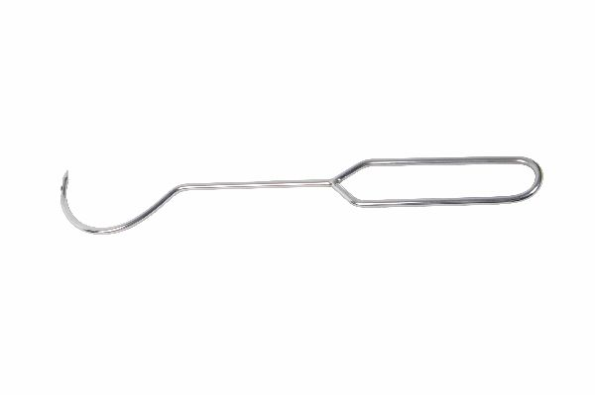
Function
The introducer carries an eye at its distal tip through which the Gigli wire end is threaded. The instrument is passed around the bone using the Gigli saw guide channel, and the wire is pulled through behind it. Once the wire emerges on the contralateral side, the introducer is removed and the saw handles are attached.
Advantages
Atraumatic Wire Threading: The smooth, rounded introducer body threads the wire without catching on periosteum, fascial bands or vessels, preventing the wire from dragging rough edges through the subperiosteal space that could lacerate tissues during threading.
Precise Wire Level Control: The introducer positions the wire at exactly the level of the saw guide, ensuring the cut will be made at the intended anatomical level rather than drifting proximally or distally during wire threading through soft tissue.
FAQ
Q: Can one introducer be used for all Gigli wire gauges?
A: The introducer eye must be sized for the wire gauge being used; an eye that is too small for thick wire prevents threading, while too large an eye allows the wire to slip around within the eye and bunch during threading.
Q: What is the difference between the Gigli guide and the introducer?
A: The guide is a rigid curved instrument that pre-establishes the subperiosteal route; the introducer threads the wire through the established route — they are used sequentially in the wire placement procedure.

ORTHOPAEDIC INSTRUMENTS
Other Instruments
Gigli Saw Wire
Intended Use
The Gigli saw wire is a flexible braided wire saw used for bone division through a pull-cutting action in veterinary orthopaedic, oncological and thoracic surgical procedures. It is the consumable cutting element of the Gigli saw system, providing bone division in anatomical locations where rigid saw access is impossible. | 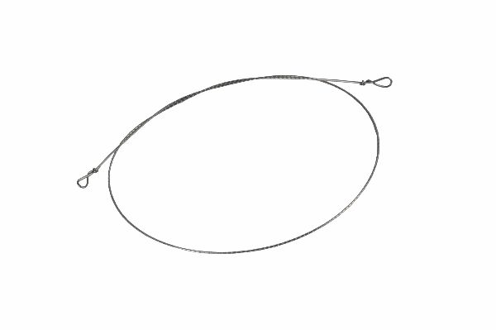
Function
The braided wire construction carries multiple helical cutting edges along its length. When drawn alternately from each end across the bone surface, these cutting edges abrade and cut through cortical and cancellous bone in a progressive sawing action. The flexible wire conforms to the bone geometry, cutting along the contact surface.
Advantages
Access to Surgically Confined Bones: The flexible Gigli wire can be positioned around bones that rigid saws cannot reach, enabling bone division in the thoracic cavity, mandible, pelvic ring, and vertebral body — locations critical for large tumour resection and complex fracture repair in veterinary oncological surgery.
Single-Use Cutting Reliability: As a single-use consumable, each Gigli wire is sharp from the first stroke, providing consistent cutting efficiency without the dulling that reused saws exhibit — important for time-efficient bone division in lengthy oncological resection procedures.
FAQ
Q: What gauge Gigli wire is most commonly used in veterinary surgery?
A: Medium gauge (0.7–1.0 mm) is the most common for canine long bone and mandibular division; fine gauge (0.5 mm) is used in cats and toy breeds; heavy gauge (1.2 mm) for equine and large bone procedures.
Q: How is wire breakage during sawing prevented?
A: Maintain adequate tension throughout the cut, apply continuous saline irrigation, and saw with smooth reciprocating strokes — jerky or excessive-force strokes fatigue the wire and cause breakage.

ORTHOPAEDIC INSTRUMENTS
Other Instruments
Hammer – S.S. Handle
Intended Use
The stainless steel handled orthopaedic hammer is the primary impact instrument used across veterinary bone surgery for driving chisels, osteotomes, awls, impactors, and bone tamps. Its balanced weight and durable SS construction make it the standard mallet for all impaction needs in the veterinary orthopaedic theatre. | 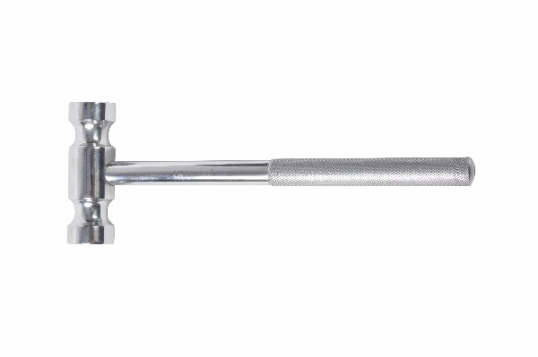
Function
A precision-balanced SS head delivers repeatable, controlled impact force when swung against the instrument being driven. The ergonomic handle transmits vibration feedback from the impacted instrument to the surgeon's hand, providing tactile information about instrument progress and breakthrough through bone.
Advantages
Universal Impaction Coverage: A single SS orthopaedic hammer serves every impaction need in the veterinary theatre — chisel driving, awl entry, nail advancement, tamp impaction, and implant seating — eliminating the need for multiple mallets of different weights on the sterile tray.
Autoclave-Permanent Construction: All-stainless construction with no polymer, rubber, or wood components withstands unlimited autoclave cycles at 134°C, maintaining impact mass, balance, and handle integrity throughout the instrument's long service life in high-throughput surgical environments.
FAQ
Q: What weight SS hammer is used for bone plating procedures?
A: A 250–400 g head weight is standard for general orthopaedic bone work; lighter hammers (150 g) are used for fine dental and craniofacial instrument driving; heavier (500 g+) for amputation saw guidance and large bone work.
Q: How is hammer swing controlled to avoid adjacent tissue injury?
A: The surgeon's non-dominant hand steadies the driven instrument while the dominant hand controls the hammer strike; short, accurate strokes are used rather than wide swings, especially in confined wounds near neurovascular structures.

ORTHOPAEDIC INSTRUMENTS
Other Instruments
Mini Plate Cutter (Vertical)
Intended Use
The mini plate cutter vertical model is used to trim stainless steel or titanium mini bone plates to the correct length during small animal fracture plating procedures. It cuts through plate holes between screws, shortening the plate to the optimal length for the specific fracture configuration without deforming the adjacent hole geometry. | 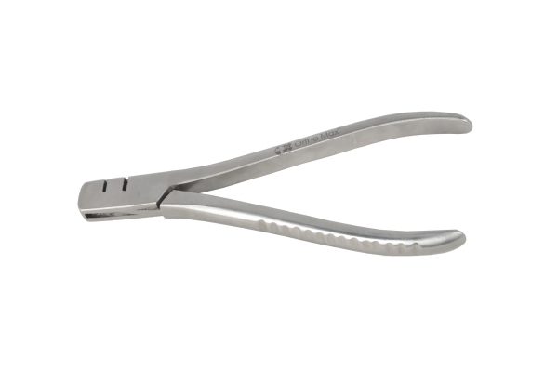
Function
The cutter jaws are positioned between two plate holes at the intended cut location. Closing the handles drives the hardened blades through the plate cross-section in a single shearing stroke. The vertical cutting orientation allows the blades to cut perpendicular to the plate face, producing a clean flat cut end without the curling that diagonal cutters create.
Advantages
Perpendicular Clean Cut: The vertical cutting orientation shears the plate end squarely, producing a flat cut surface without the metal curling that angular cutter geometry creates — curled plate ends create stress risers and cause soft tissue irritation if not filed smooth after angular cutting.
Hole Geometry Preservation: Cutting precisely between holes preserves the adjacent screw hole geometry, ensuring the last plate hole remains usable for a screw after cutting — critical for maximising the number of screws per plate in short plate constructs.
FAQ
Q: Can the mini plate cutter cut locking plates?
A: Most mini locking plates are the same thickness as standard plates and can be cut with this instrument; ensure the cutter's rated plate thickness matches the plate being cut, as thick locking plates may exceed the cutter's capacity.
Q: Should the cut plate end be smoothed after cutting?
A: Yes — the cut end should be filed smooth with a bone file to remove any sharp corners or burrs that could cause soft tissue irritation through the overlying subcutaneous tissue.

ORTHOPAEDIC INSTRUMENTS
Other Instruments
Nasal Saw
Intended Use
The nasal saw is a specialised hand saw used for nasal bone resection, turbinectomy, and nasal cavity reconstructive procedures in veterinary patients. It is used in brachycephalic obstructive airway syndrome (BOAS) correction, nasal tumour surgery, and nasal fracture repair requiring bone resection in dogs and cats. | 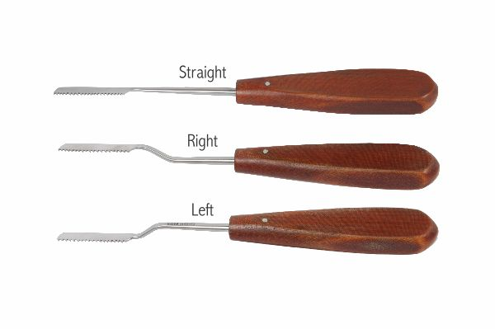
Function
The narrow, angled blade carries fine teeth suited to the thin, irregular nasal bones. The blade angle allows the surgeon to direct the cut along the nasal bone surface from an anterior approach without the handle obstructing the limited access to the nasal cavity in small animal patients.
Advantages
Nasal Anatomy Access: The narrow blade width and angled handle profile are designed to fit within the restricted nasal opening of brachycephalic and dolichocephalic breeds, accessing the nasal bones and turbinates that standard saws are too wide or straight to reach.
Fine Tooth Precision: The fine tooth pattern cuts through the thin, porous nasal bones with minimal force, reducing the vibration that coarser saw blades transmit to the cribriform plate and adjacent orbital structures during nasal bone resection.
FAQ
Q: In which veterinary procedures is the nasal saw most commonly used?
A: BOAS nasal planum widening, nasal turbinectomy for airway correction in brachycephalic breeds, nasal tumour resection, and nasal bone fracture repair requiring fragment removal are the primary veterinary indications.
Q: How is the nasal saw blade length selected?
A: Blade length should exceed the nasal cavity depth by 2–3 cm to allow the full cut to be made without withdrawing the saw mid-cut; blades that are too short require multiple partial strokes that increase the risk of blade walking.

ORTHOPAEDIC INSTRUMENTS
Other Instruments
Nylon Faced Hammer
Intended Use
The nylon faced hammer is used for implant seating, prosthesis positioning, and fragment repositioning in veterinary orthopaedic surgery where a metal-faced mallet would damage the implant or bone surface. The nylon face cushions the impact, protecting polished implant surfaces from metal-to-metal contact marks. | 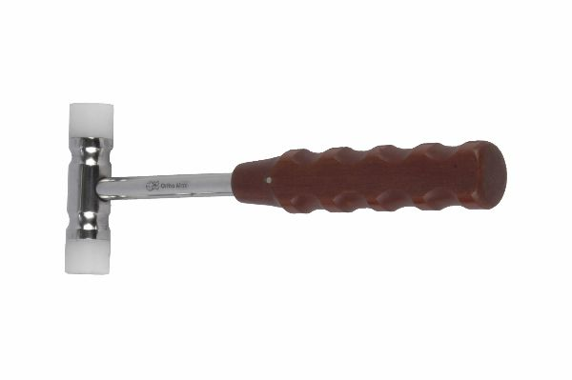
Function
A removable or permanent nylon insert in the hammer face contacts the instrument or implant being struck. The nylon deforms slightly on impact, absorbing the peak impact force and converting it to a broader, lower-peak impulse that seats the implant without marking the metal surface or transmitting bone-cracking shock loads.
Advantages
Implant Surface Protection: The nylon face prevents metal-to-metal contact marks on polished prosthetic surfaces and implant heads that would compromise the surface finish, potentially initiating corrosion sites or stress concentration at scratch marks in load-bearing implants.
Controlled Low-Shock Seating: The nylon's impact-absorbing properties convert sharp metal-hammer impacts into broader force pulses that seat implants progressively without transmitting sudden bone-cracking shock loads through the implant into the adjacent cancellous bone during prosthesis impaction.
FAQ
Q: When should the nylon faced hammer replace the SS hammer?
A: Use the nylon hammer whenever the struck surface is a finished implant, prosthesis, or delicate instrument tip; use the SS hammer for driving chisels, awls, and instruments with hardened metal proximal faces designed for metal-to-metal impact.
Q: How often should the nylon face be replaced?
A: Nylon faces develop impact depressions that concentrate force at the face edges after 50–100 heavy strikes; replace when visible deformation is observed or when centred impact is no longer reliably achieved.

ORTHOPAEDIC INSTRUMENTS
Other Instruments
Suction Cannula – Mastoid
Intended Use
The mastoid suction cannula is a fine-bore suction instrument used to evacuate blood, bone debris, and fluid from confined operative fields in veterinary orthopaedic, aural, and neurological surgical procedures. Its angled, narrow bore reaches into deep wound cavities and osseous structures inaccessible to standard suction tips. | 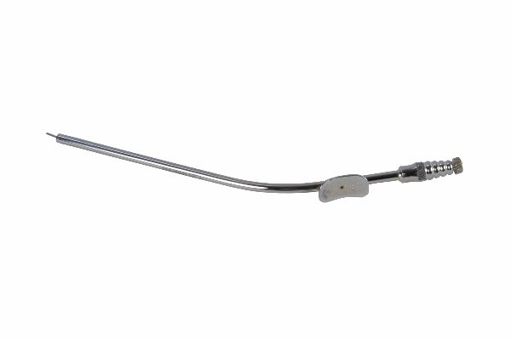
Function
The angled, narrow metal cannula is connected to the suction circuit and introduced into the target cavity. Suction pressure draws blood and debris into the tip and through the cannula to waste. The fine bore allows precise positioning within small bone cavities such as the middle ear bulla, vertebral canal, and mini bone plating wound beds.
Advantages
Deep Cavity Access: The angled narrow cannula reaches into bony cavities and deep soft tissue spaces that standard Yankauer suction tips cannot access, providing effective haemostasis and wound clearance in ventral bulla osteotomy, laminectomy, and deep long bone wound decompression.
Precise Blood Field Clearance: The narrow bore removes blood precisely from the specific location where the surgeon is working without the wide-area suction of broader cannulas, maintaining a clear operating field without repeatedly disturbing adjacent tissue.
FAQ
Q: What suction pressure is appropriate for the mastoid cannula?
A: Moderate suction (40–80 mmHg) is appropriate; excessive suction at the fine bore causes the cannula to occlude against the wound wall and damages delicate tissues such as dura and middle ear mucosa.
Q: How is the cannula kept from occluding during surgery?
A: Momentarily releasing suction by removing the thumb from the vent hole or retracting the tip slightly clears soft tissue occlusions; never advance a clogged cannula forcefully as this risks tissue damage.

ORTHOPAEDIC INSTRUMENTS
Other Instruments
Tendon Stripper
Intended Use
The tendon stripper is used to harvest free tendon grafts for reconstructive procedures in veterinary orthopaedic surgery, including cranial cruciate ligament repair with autologous tendon graft, tendon transfer operations, and joint ligament reconstruction using harvested tendon material from the patient. | 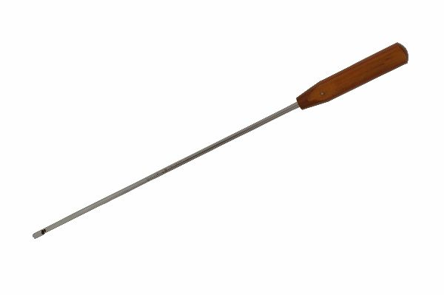
Function
A tubular or loop-bladed working tip passes over the tendon's free end and is advanced along its length. The sharp leading edge severs the tendon's paratenon and peritendinous attachments progressively as the instrument is pushed distally, harvesting a graft of defined length from the proximal end to the point where the leading edge transects the tendon.
Advantages
Minimises Donor Site Morbidity: The stripper harvests the graft through a single small proximal incision without exposing the full tendon length, reducing the soft tissue dissection required and preserving the surrounding paratenon blood supply that supports the remaining tendon stump.
Defined Graft Length Control: The length of tendon harvested is directly controlled by how far the stripper is advanced before transecting; this allows the surgeon to harvest a graft of the exact length needed for the reconstruction without cutting a longer graft that wastes tendon.
FAQ
Q: Which tendons are harvested for veterinary cruciate repair?
A: The long digital extensor tendon, fascia lata strip, and semitendinosus tendon are most commonly harvested for extra-articular cranial cruciate ligament repair and stifle stabilisation procedures in dogs.
Q: Can the tendon stripper be used for fascia harvesting?
A: No — the stripper is designed for round, tubular tendon structures; fascial strips require sharp scissors or fasciatome instruments designed for flat tissue sheet harvesting.

ORTHOPAEDIC INSTRUMENTS
Other Instruments
Tendon Tunnelling Forceps
Intended Use
Tendon tunnelling forceps are used to create a passage through soft tissue and to draw tendon grafts, sutures, and prosthetic ligaments through tunnels during veterinary orthopaedic reconstructive procedures. They enable precise graft routing through tight anatomical spaces in ligament reconstruction and tendon transposition surgery. | 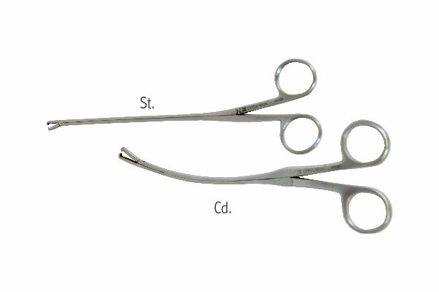
Function
The tapered, blunt-nosed tip is pushed or tunnelled through soft tissue planes following the desired graft route. Once through, the tip clamps onto the graft or suture leader and draws it back through the tunnel in a controlled, smooth motion without bunching or damaging the graft surface during tunnel passage.
Advantages
Atraumatic Graft Passage: The smooth, blunt tunnelling tip separates tissue planes rather than cutting through them, creating a graft channel that heals around the tendon and maintains vascularity to adjacent structures critical for the biologic integration of reconstructed ligament or tendon.
Precise Routing in Complex Anatomy: The slim, directional tip follows specific anatomical paths through complex soft tissue configurations, enabling graft routing through pericapsular tunnels, bone drill holes, and inter-muscular planes that cannot be navigated with blunt instrument tips.
FAQ
Q: What graft materials are passed with the tunnelling forceps?
A: Autologous tendon grafts, synthetic polyester prosthetic ligaments, and heavy monofilament suture leaders for ligament repair are the most commonly passed materials in canine stifle and shoulder reconstruction procedures.
Q: How is graft damage during tunnel passage prevented?
A: The graft end is securely clamped in the forceps tip before passage; maintain consistent tunnel diameter and avoid sharp bends in the graft path that would cause the graft to compress and fray as it is drawn through.

